**SHITTAUNG PAGODAS FESTIVAL**

**The Shaitthaung Temple**, also spelled **Shitthaung** according to Standard Burmese pronunciation, is a famous temple in Mrauk U. The name means ‘Temple of 80,000 Buddha Images’, and is also known as the ‘Temple of Victory’.

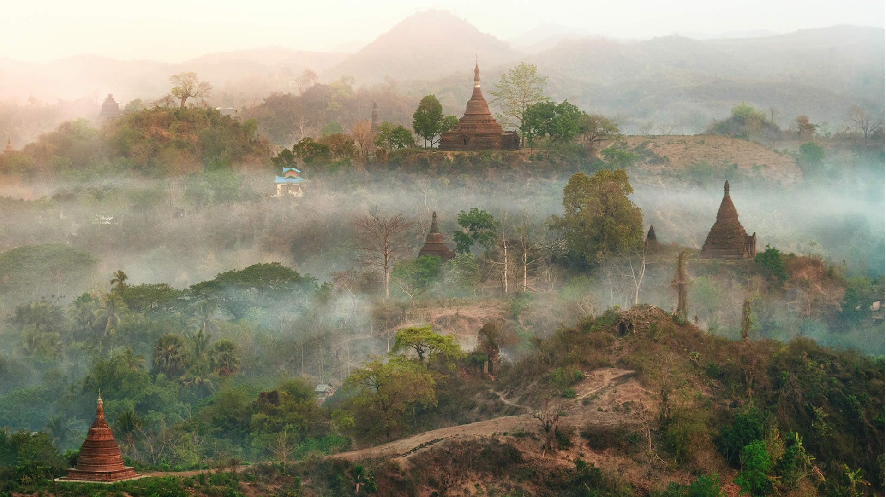

Among the most popular festival of the Rakhine people of Myanmar, the Shittaung Pagoda Festival is held in April every year. The festival is a traditional pagoda festival where candles are lit and flowers given to pay homage to the local pagoda. The modern-day festival continues the tradition of the Rakhine people of partaking in sporting events on the day of the pagoda festival. The festival is held in the Rakhine town of Mrauk U.

*Source: Internet*